

Bilateral integration in virtual reality

Interim Report

DT211C

BSc in computer science infrastructure

**Mykolas Kubilius**

**C20321456**

**Dr Bryan Duggan**

School of Computer Science

Technological University, Dublin

**15/11/2023**

Abstract

Virtual reality is becoming really popular in the science industry such as the medical and psychological fields. virtual reality is being used by people to help others with mental health problems and other mental challenges, but how would the virtual world help people who have different types of disabilities or different type of mental challenges?

Virtual reality can help people by creating a virtual environment that is both safe and user friendly, it also provides a fun and engaging experience for users which will encourage them for frequent usage that aims to improve their mental health. Bilateral integration is what I am currently focusing on as I see that it has a lot of potential to help out kids with mental difficulties work on coordination, there are currently real-world example of exercises used by teachers and therapists. This report details all the development of a bilateral integration exercises in VR using the game engine Godot which will be implemented into the Meta Quest 3, the whole game will be coded in Godots very own language called GDscript, but it also uses C++ and C#. the report will also cover the creation of 3D objects and assets as well as game mechanics and integration of VR features such as grabbing different 3D objects and interaction with the virtual environment. Several test cases will be provided to test out each induvial levels that contain different types of bilateral integration exercises to see if it matches the requirements for a healthy and useful exercises to help out the kids. This project will greatly benefit young kids with mental challenges to overcome their lack of hand and eye coordination.

Declaration

I hereby declare that the work described in this dissertation is, except where otherwise stated, entirely my own work and has not been submitted as an exercise for a degree at this or any other university.

Signed:

Mykolas Kubilius___

15/11/2023

Acknowledgements

I would like to thank my supervisor Bryan Duggan for all his help and being a big influence and inspiration to undergo this project. I have never done game design or design anything VR related. But with his teaching skills I started to love working with games and developing VR related projects like this current one. I never would have imagined myself doing game design until 4th year. I have had little experience with making games by using Scratch but now I’m using Godot a game engine I haven’t seen or tried before, it took around 2-3 weeks to get comfortable with the game engine and understand basic usage of the tools that Godot provides.

Table of Contents

1. Introduction 7

1.1. Project Background 7

1.2. Project Description 8

1.3. Project Aims and Objectives 8

1.4. Project Scope 9

1.5. Thesis Roadmap 9

2. Literature Review 11

2.1. Introduction 11

2.2. Alternative Existing Solutions to Your Problem 11

2.2.1 Amelia by XRHealth 11

2.3. Technologies you’ve researched. 12

2.3.1 Meta Quest 3 12

2.3.2 Godot 14

2.3.3 Unreal Engine 5 (UE5) 16

2.4. Other Research you’ve done 18

2.4.1 XR interaction toolkit 18

2.5. Existing Final Year Projects 19

2.5.1 Project 1: VR Safari 19

2.5.2 Project 2: EvolVR- Investigating procedural Ecosystems and Evolution 19

2.6. Conclusions 19

3. System Design 20

3.1. Introduction 20

3.2. Software Methodology 20

3.2.1 Agile Methodology 20

3.2.2 Waterfall Methodology 21

3.3. Overview of System 22

3.3.1 Flow chart diagram 23

3.3.2 Meta quest 3: 24

3.3.3 Use case diagram 25

3.3.4 Godot 26

3.3.5 GDScript 28

3.4. Godot Audio system 31

3.5 Conclusions 32

4. Testing and Evaluation 34

4.1. Introduction 34

4.2.1 Plan for Testing 34

4.2.2 Steps in installing Godot game engine. 34

4.2.3 Getting the project folders and importing project.godot 36

4.2.4 Opening the game onto Godot. 37

4.3.1 Plan for Evaluation 39

4.4. Conclusions 39

5. Prototype Development 40

5.1. Introduction 40

5.2. Prototype Development 40

5.2.1 Loading screening/start scene. 40

5.2.3 Main menu room 40

5.2.4 Pickable demo scene 42

5.2.5 Poke/whiteboard scene 42

5.2.6 Sprinting demo 43

5.2.7 Gliding scene 44

5.4. Conclusions 45

6. Issues and Future Work 46

6.1. Introduction 46

6.2. Issues and Risks 46

6.2.1 Social issues 46

6.2.2 Addiction and distorted sense of reality 46

6.2.3 Health problems 46

6.2.4 Privacy concerns 47

6.2.5 Benefits of using VR 47

6.3. Plans and Future Work 47

6.3.1. GANTT Chart 48

Bibliography 49

# 1. Introduction

## Project Background

What is bilateral integration otherwise known as bilateral coordination? Well, it’s the ability for both sides of the brain to work together in a coordinated manner, this is shown when the left side of the brain is working on conjunction with the skills associated with the left side of the brain and also the skills associated with the right side of the brain. In short it means that that brain works together in unison.

Skills associated with the right side of the brain.

* Creativity (thinking and imagination)
* Art, drawing and other creative skills that is artistic.
* Musical skills

Skills associated with the left side of the brain.

* Speech and language
* Problem solving
* Handwriting
* Logic
* Memory for spoken/written messages.
* Linear thinking

Bilateral coordination develops from a young age, its noticed when a newborn starts to use both of their hands near their mouths like a milk bottle, when the child grows it begins to use its hands to crawl by using both hands to push the body forward one step at a time.

But not all babies have the skills to move their hands in unison. Sometimes differently mental health problems hinder that, those kids don’t have bilateral coordination since they weren’t thought it. Which is why there are plenty of exercises that help out with helping the kids achieve bilateral coordination. These exercises can include,

* Tying a shoelace
* Typing
* Writing
* Playing an instrument
* Pouring water into a cup
* Reaching out for objects
* Bouncing a balloon in the air with a broomstick

(1)

## Project Description

The project’s main goal and objective is to develop a simple level-based game that contains a different set of bilateral integration exercises that is currently being used in the real world. Using these examples, the game will contain a safe and fun virtual environment that the user with coordination difficulties can easily pick up a VR headset and pick up the controls then they can dive straight into the levels and test out how well their brains can coordinate together as there is a left side and right side of the brain. These exercises can range from holding a broomstick or a long stick with both controllers using the grip VR feature and have a light balloon like 3D object bounce up in the air every time the user uses the stick to push the object upwards. Other exercises can involve using both hands to hold a virtual marker and draw something on a whiteboard or use one hand to draw the infinity symbol over and over again until they keep their marker inside of the line.

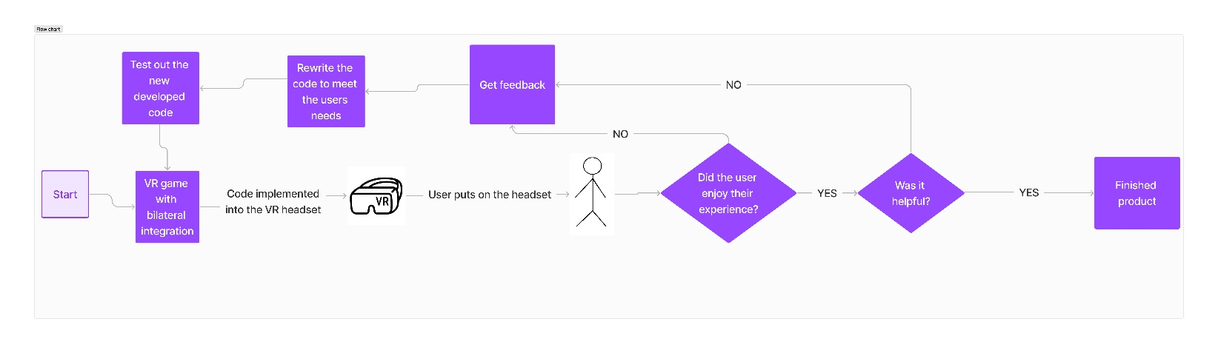

## Project Aims and Objectives

My main objective is to implement a VR game that has different types of levels that have different exercise implemented into each level. I want my users to feel like that VR experience is helping them out with bilateral coordination and that it encourages them to keep playing the games and helping them with their bilateral coordination.

Make an immersive experience that involves adding an immersive environment like a classroom or the outdoors where the user can interact with objects or scenarios that need the usage of both hands.

Develop hand-eye coordination that demands the users to coordinate between hand movements and visual perception which will help the users hand and eye coordination in a VR environment.

Educational purposes that allow the development of using both hands in unison that aids in learning through interactive tasks such as writing on a whiteboard.

Implement gameplay mechanics that require users to use both hands effectively, adding that engagement to gaming experiences.

Implement user feedback and progress tracking, this helps provide a friendly and productive user experience for the individual. The progress tracking enables users and teachers to monitor their improvements overtime.

## Project Scope

This project will focus on developing a level-based VR game that contains different types of bilateral integration exercises. The whole game will be made using Godot in a simple 3D safe world environment where it will be played on the Meta Quest 3. The user should be able to easily pick up the headset and put it on, hold both of the controllers in each hand and follow along with the instructions that are placed inside of each level, this allows the user to understand what task they have to accomplish in order to proceed to the next level.

I won’t be implementing accounts for each user as I think that would take a longer time to implement since it would require each user to have the perfect settings. It would be easier that way since I will be focusing on perfecting the exercises for each level that the kids could enjoy. I will also not implement a multiplayer functionality so that there won’t be a need for account registration or any profile making so that way the user can simply put on the headset and start learning and training their brains to use hand-eye coordination.

I would like to add an EEG headset, it essentially monitors and records the electrical activity of the Brain, the EEG headsets have been used for recording brain activities for clinical and medical purposes. The EEG electrodes are able to pick up brain activity and it is sent to a mobile or computer for storage and data processing since the collected signals are amplified and digitized for such purpose. The reason for not adding it in is due to the cost of the EEG headsets as one headset can cost around €2,500. And also, the fact that it can be a difficult way to implement into the game as it requires that the headset be configured to the game engine.

(2)

(3)

## Thesis Roadmap

Chapter 2:

Application research and background research on bilateral integration.

Chapter 3:

Software design methodology and review of how the system will operate.

Chapter 4:

Plans for testing the project and plans for evaluation. Steps to install the project.

Chapter 5:

The development of the prototype and explanation of each scene used in the project.

Chapter 6:

Issues and risks involving VR and plans for future work for the project.

# Literature Review

## 2.1. Introduction

In this chapter, I will discuss about similar alternative approaches to mental heal problems that involves the usage of virtual reality.

## 2.2. Alternative Existing Solutions to Your Problem

There are a few companies that use virtual reality to help with mental health, they dive to help out using meditation and other science-based technologies, but my project focuses on bilateral coordination, this does fall under the mental health category, but my project focuses on helping one problem.

### 2.2.1 Amelia by XRHealth

The Amelia VR Platform is easy to use, fast, and affordable. Amelia Virtual Care – formerly known as Psious – provides a virtual reality platform used by therapists who perform mental health assessments and interventions. Through close collaboration with leading public and private institutions, we are proud to advance research and promote evidence-based care for better mental-health practices, globally.

The benefits of VR in mental health are supported by 30+ years of evidence and over 1000+ studies. As evidence of the advantages of VR in mental health accumulated, adoption of its use by mental health professionals has steadily grown.

Their mission is to improve mental health through the use of science-based new technologies and their vision is to become the world leader of virtual reality in healthcare.

They value a positive social impact.

They value a global mindset.

They value Entrepreneurship.

They value Passion & empathy.

Their history

The name Amelia Virtual Care comes from the first-ever woman to fly across the Atlantic Ocean, Amelia Earhart.

Amelia left England for the United States on an air crossing that lasted more than 20 hours and 40 minutes–a daring accomplishment that went against predictions and showcased her tenacity.

Xavier Palomer, Founder of Amelia.

“Amelia started in 2014 while I was having a drink with two friends 8 years ago. The first one was afraid of flying and mentioned the problems generated by this situation. The other one, a psychologist, responded how VR could be a tool to address his problem.

I found out that literature regarding VR technology was extensive and scientific validation quite robust. Yet, despite this incredible background, the technology was not accessible to professionals and patients worldwide. I saw an opportunity. At Amelia, we bring technology based on VR to a market-ready solution. This is our core!”



(4)

## 2.3. Technologies you’ve researched.

A virtual reality game can be implemented using a wide variety of technologies and software’s, underneath is a list of technologies that I have investigated.

### 2.3.1 Meta Quest 3

The Meta Quest 3 which can be also commonly known as Oculus Quest 3 is a virtual reality headset that was developed by Meta platform and Meta is founded by Mark Zuckerberg. Meta officially revealed the Meta Quest 3 on June 1st and then launched the headset through the Meta Connect 2023 event on September 27. During the online livestream, Meta confirmed that the Quest 3 will start shipping on October 10, 2023, with pre-orders going live right after the announcement was done. the Meta Quest 3 provides a 4K+ Infinite Display (2 LCDs with 2064 x 2208 pixels per eye) with a field of view by 110 degrees horizontal, 96 degrees vertical. It has a refresh rate of 90Hz (native), 120Hz (experimental), it weighs around 515 grams and has a storage capacity of 128GB or 512GB. It uses a Qualcomm Snapdragon XR2 Gen 2 CPU

(5)

The Meta Quest headsets are commonly used for Virtual reality gaming. As shown in the previous diagram, the Oculus Quest 2 was the leading in unit sales then the other VR headsets.

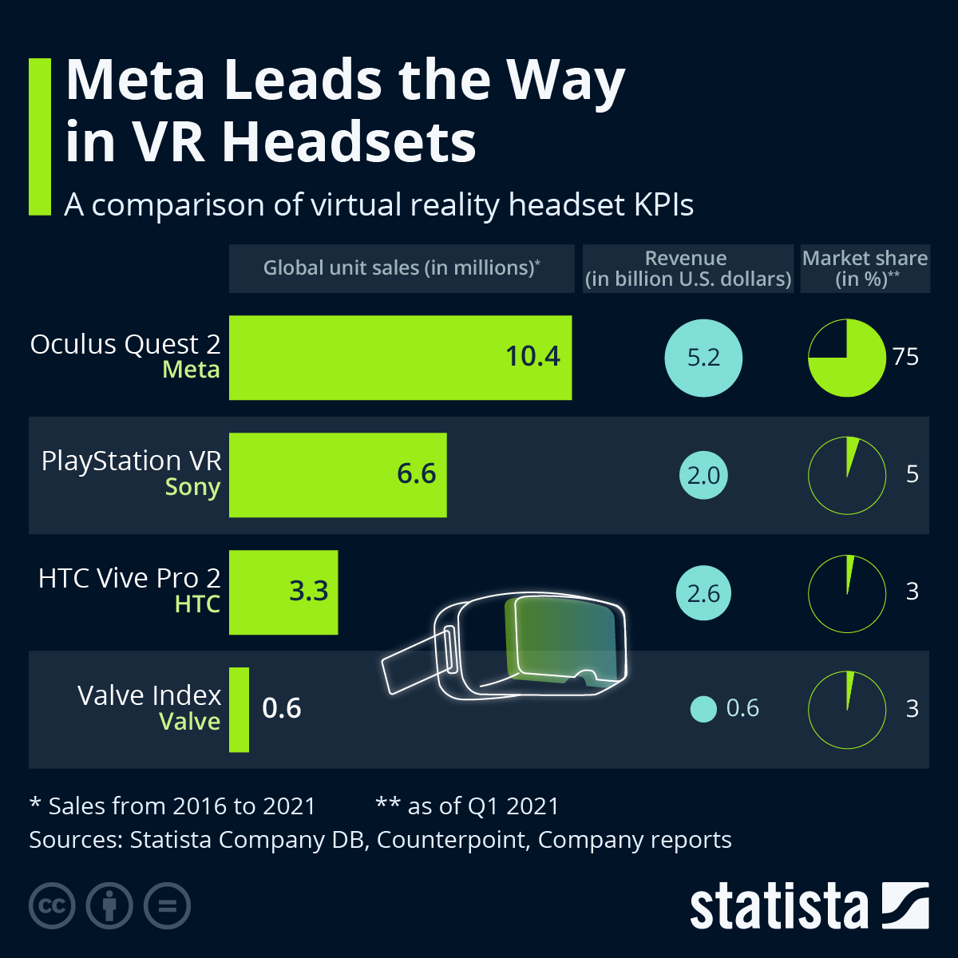

(6)

### 2.3.2 Godot

Godot is a general purpose 2D and 3D game engine that is designed to support all sorts of projects, it can be used to create games or applications that can be released on desktop or on mobile devices, as well as being published on the web. Godot was developed by an Argentinian game studio and its development started in 2001 before having its open source released in 2014. Below are some images of games that were created using Godot

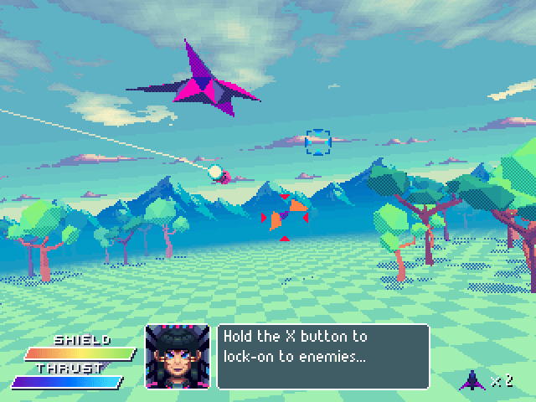

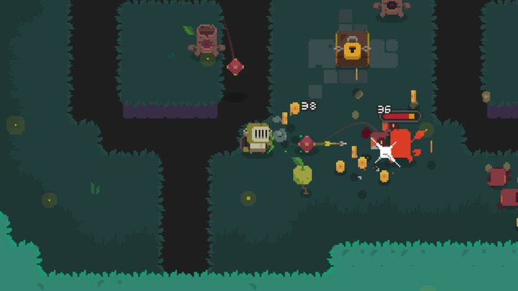

Godot comes with a fully-fledged game editor with integrated tools that answers most people’s common needs. This includes a code editor, an animation editor, a tile map editor, a shader editor, a debugger, a profiler and many more. Below is an illustration of what Godot has to offer.

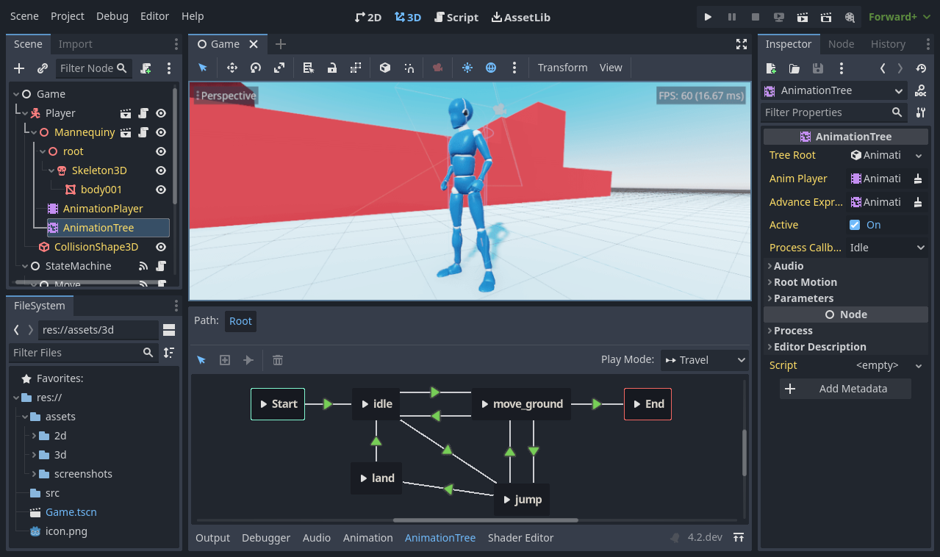

Godot offers its very own programming language called GDscript, you can also code in C# which is the more popular programming language for developing games, but with GDExtensions, you can write gameplay or develop high-performance algorithms in C or C++ without compiling the engine.

(7)

### 2.3.3 Unreal Engine 5 (UE5)

The unreal Engine 5 is the latest version of unreal Engine, its one of the most powerful and popular game engines that contains features such as Nanite, Lumen, World partition system, Meta Sounds, and animations.

Nanite:

The unreal engine 5 uses nanite which is a virtualized geometry system that saves you the time when designing massive amounts of geometric detail, the enables designers to create wide ranges of surfaces. It also eliminates tedious tasks for loading in level of details and allows you to import film-quality art. With nanite you can just scan and go and not have to worry since it doesn’t impact performance and you would still get a real-time frame rate.

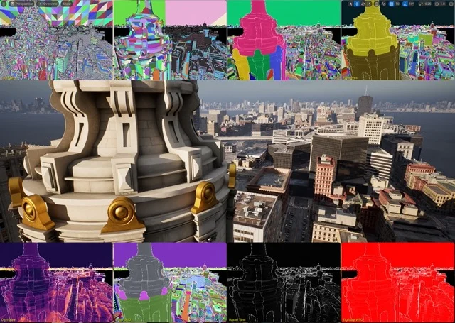

Lumen:

Lumen creates a realistic virtual world that comes down to lighting, with a fully dynamic global illuminations and reflections. Lumen allows you to make indirect lighting which reacts to direct lighting and geometry. For example, lighting can be adjusted to match the times of day and night using a light source like the sun, you can also create a flashlight that creates a beam of light. Lumen adjusts lighting from open, dynamic scenes down to the tiniest details.

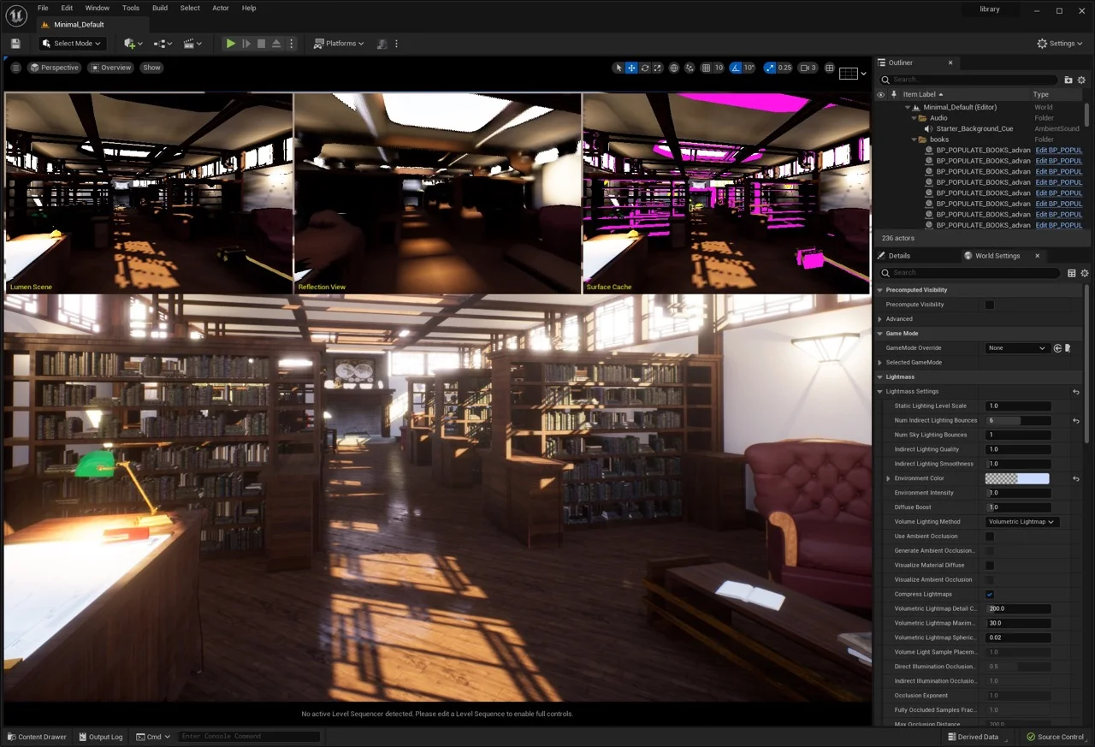

World Partition:

Unreal engine 4 is known for allowing users to create open world. But unreal engine 5 lets you accelerate the creation of large-scale world building and makes it easier to collaborate. The world partition system uses a grid to map out sublevels of an entire universe. You can manage complex levels that can load and unload as a player goes across the landscape. Also, the one file per actor system helps teams work in parallel. It reduced overlap by saving data as external files per contributor.

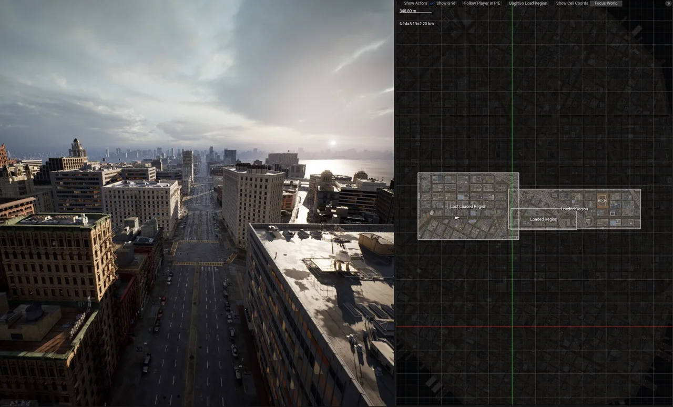

(8)

## 2.4. Other Research you’ve done

### 2.4.1 XR interaction toolkit

Godot’s XR toolkit provides the user a with a modular XR system that abstracts many of the different XR platform specifics away from the user. At its core sits the XRserver which acts as the central interface to the XR system that allows users to discover interfaces and interact with the components of the XR system

Each supported XR platform is implemented as an XRInterface. Supported interfaces register themselves with the XRServer and can be queried with the find_Interface method on the XRServer. When the desired interface is found it can be initialised by calling initialize on the interface.

OpenXR is a new industry standard that allows different XR platforms to present themselves through a standardised API to XR applications. This standard is an open standard maintained by the Khronos Group and thus aligns very well with Godots interests.

The Vulkan implementation of OpenXR is closely integrated with Vulkan, taking over part of the Vulkan system. This requires tight integration of certain core graphics features in the Vulkan renderer which are needed before the XR system is setup. This was one of the main deciding factors to include OpenXR as a core interface.

(9)

## 2.5. Existing Final Year Projects

### 2.5.1 Project 1: VR Safari

Student: Elihu Essien-Thompson

Description (brief):

VR safari is a game where the user is placed into a Safari viewing experience while attempting to take pictures of the animals to gain points while the animals roam freely. The player is allowed five minutes to gain points before the game is over and the score is shown.

### 2.5.2 Project 2: EvolVR- Investigating procedural Ecosystems and Evolution

Student: Ryan Bryne

Description (brief):

The project aims to make a virtual ecosystem with diverse animal groups while simulating their evolution over time. These animals adapt to procedurally generated environments by passing their traits through genetic mutations. The animals AI is being controlled by a behaviour tree.

## 2.6. Conclusions

A well designed and written game that is used to help people with bilateral integration requires extensive and comprehensive research and also requires the accurate utilization of technology. This project utilized the Godot game engine for modelling the objects and the world while using Godots own language GDscript to write out scripts and the game is available to be played on any Meta Quest.

# 3. System Design

## 3.1. Introduction

This chapter expands on the detailed research regarding different software methodologies that was implemented into the VR game. Along with some early designing stages of the project.

## 3.2. Software Methodology

A software development methodology is a process by which developers design, implement and test new software programs. Following a methodology benefits developers because it lays out a structured sequence of steps that guide professionals through each stage of development. it also can follow a design philosophy, which can help developers align their process and the product’s features with its functional goals. This project was run by Agile and waterfall methodologies.

(10)

### 3.2.1 Agile Methodology

Agile methodology is a type of project management methodology. It emphasises a fast and flexible approach by allowing the development team to divide larger projects into smaller and easier to handle tasks. The team can then complete these smaller tasks in shorter iterations while gaining feedback on these smaller portions for a more consistent communication with the client and its test users. This methodology is useful for reducing while also avoiding risks, expediting development, improving customer satisfaction, and also reducing redundancies. Since developers gain client feedback through the development and testing cycle, this can be a great method to use for projects that require significant collaboration.

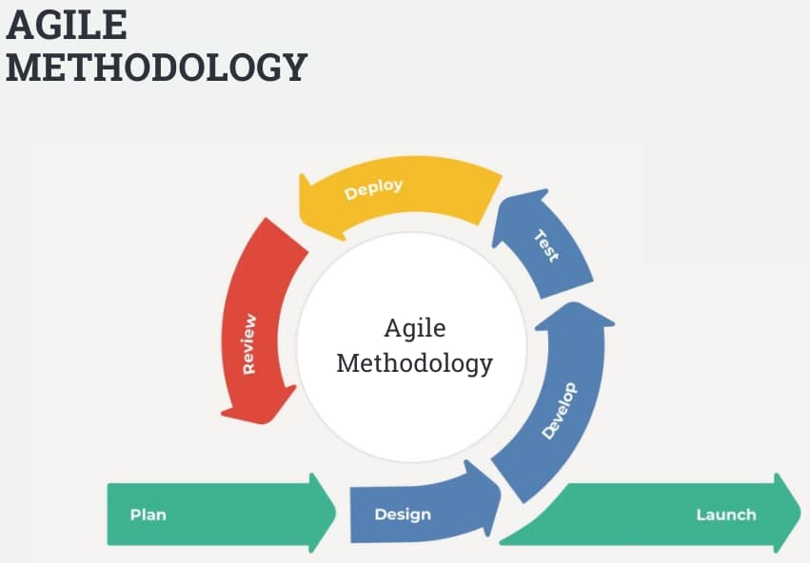

(11)

### 3.2.2 Waterfall Methodology

The waterfall methodology involves breaking a task down into a sequence of stages. With this process, developers need to complete each stage in its entirety before moving to the next step. Although this process may be less effective than those where developers can work on several stages of the project concurrently, the waterfall method is effective for ensuring thoroughness at every level of project development. this method also minimizes redundancies because it prevents overlap between tasks at different stages.

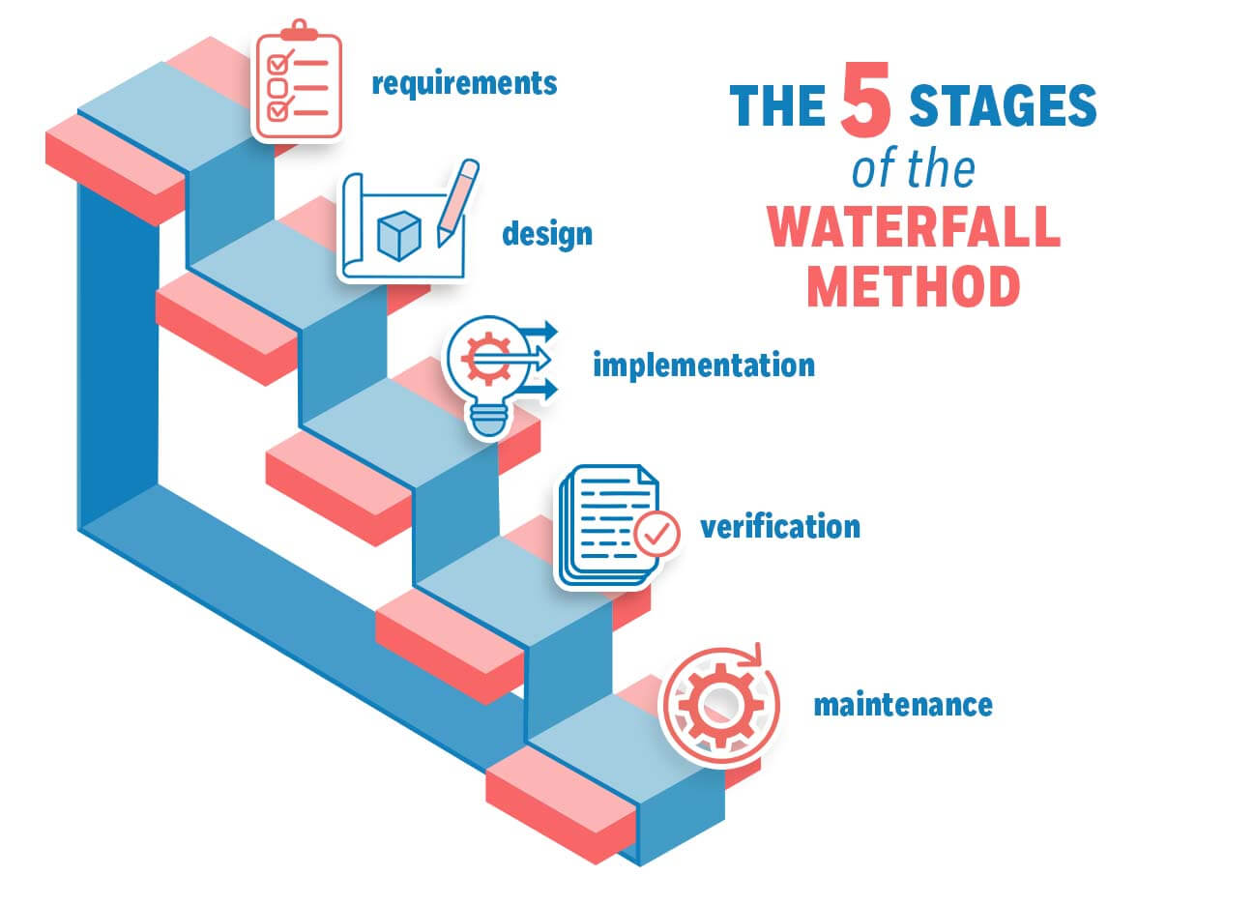

(12)

## 3.3. Overview of System

This VR game that is based on bilateral is developed using the following VR-based technical architecture. There are different components that need to help each other out in order to make a functioning VR game. For this you would need the logical layer which involves the game engine and code. And you would need the presentation layer which involves the computer as well as the VR headset and controllers.

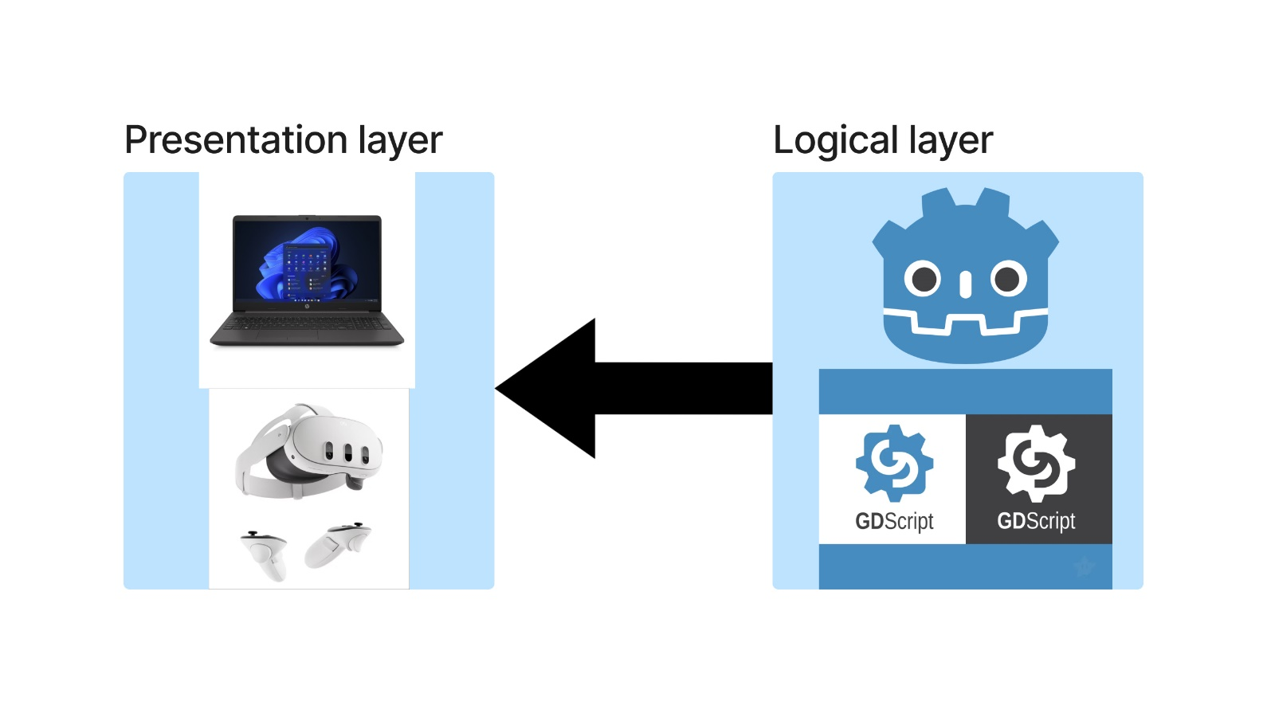

This project used a couple of technologies to make and build the project. these include the Meta quest 3 Virtual reality headset and controllers, Godot 4.1.3 game engine with the GDscript programming language. These were used to develop the bilateral integration game.

### 3.3.1 Flow chart diagram



The flow chart diagram shows the overview of what the process will look like. In the flow chart the user will put on the headset and use the controllers to play the game, the controllers are used for interaction with the virtual environment within the game. The player runs the game in a 3D environment with the headset. The player can control the behaviour of the different objects within the virtual world using the headsets controllers with both hands. The game will have levels that the player will have to perform in order to proceed to the next level. These levels use real world examples that teachers and therapists use to help young children with bilateral integration.

### 3.3.2 Meta quest 3:

In order for the player/user to feel like they are the ones doing certain actions within the game, VR heavily relies on immersion, this introduces a simulation-based technology that enables the player to interact with the virtual environment and be immersed in the world around them with different 3D objects placed for them to play around with.

### 3.3.3 Use case diagram

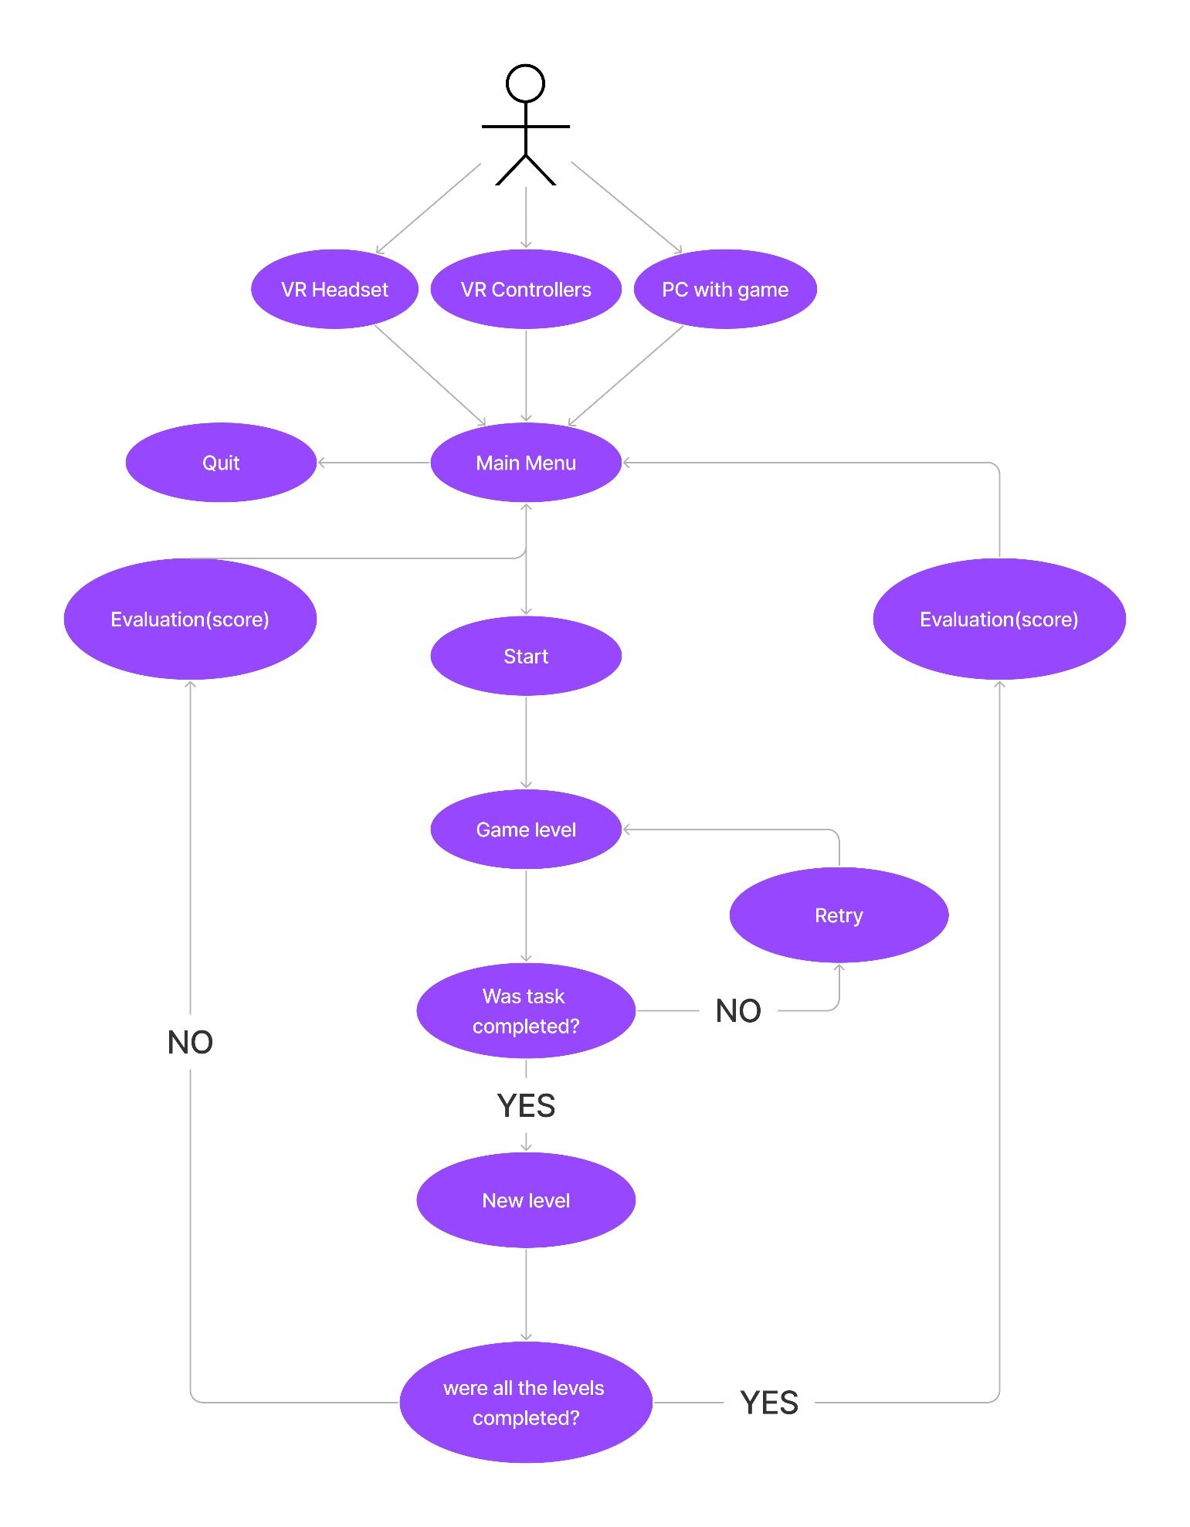

I will be using the Meta Quest 3 for game rendering the Virtual world. The User interface will be seen when using the virtual reality headset, this will allow the user to see different type of contents within the game. When the user starts the game, they will be placed in a room that hold different types of levels relevant to bilateral integration exercises. The user will step onto a platform, and they will get placed in that level. They will have to complete the level in order to get brought back to the main room with the different levels. Each level will have different things to do, like holding an object, moving your hands in a certain way. Walking or even climbing.

### 3.3.4 Godot

Godot is a game engine that is mainly used to make games, be it 2D or 3D games. You can even make VR games using the XR-Toolkit plugins that you can easily access. Using Godot to make objects within the game is easy and doesn’t require high level of coding understanding, below is an example of how a game object looks like in Godot, the mesh itself is what makes the object to appear the surface material override is where you can give the mesh a colour or give it a texture. The collision shape 3D is what gives the object collisions so that it can react with other physical objects. It gives the object collision so it can bounce off a wall if the object gets through at it. The GrabBall itself is the main node of the ball object. This uses the XR-toolkit pickable function that allows the user to be able to grab and hold the object. The node tree shows the different type of nodes that are being used to make up the ball object, and make it interact with the world and also allow it to be picked up.

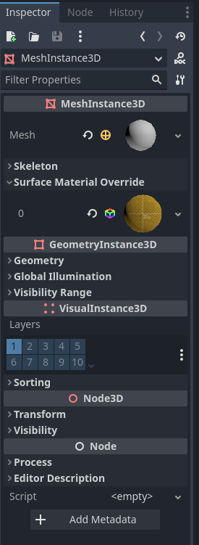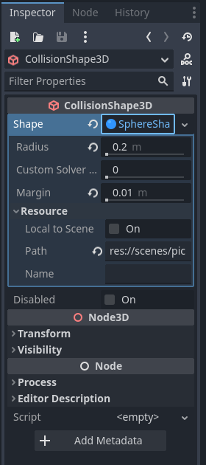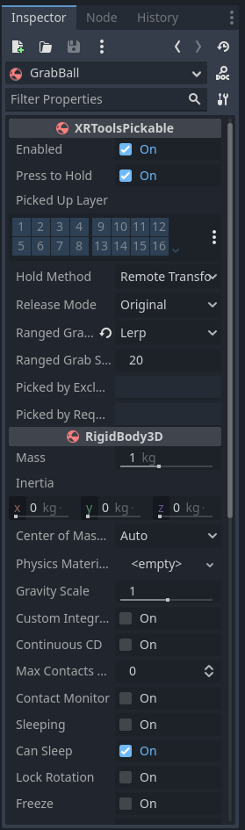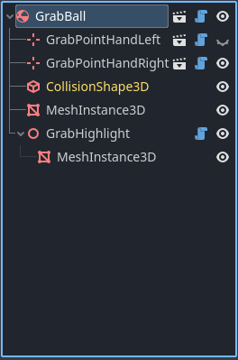

### 3.3.5 GDScript

Godot has its own programming language called GDScript, it’s a high-level, object-oriented, imperative, and gradually typed language that is built for the Godot game engine. It uses an indentation-based syntax that is similar to other programming languages like Python. The goal of GDscript is to be optimized for, and tightly integrated with the Godot game engine. This allows great flexibility for content create and integration. Below is an example of what GDScript looks like.

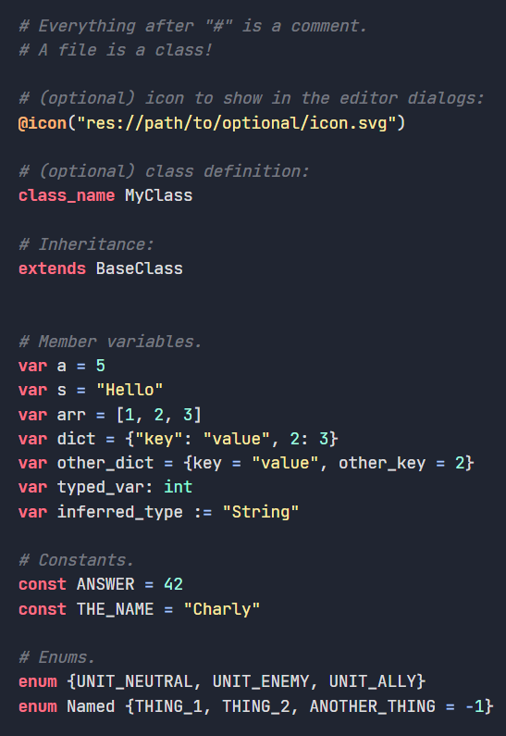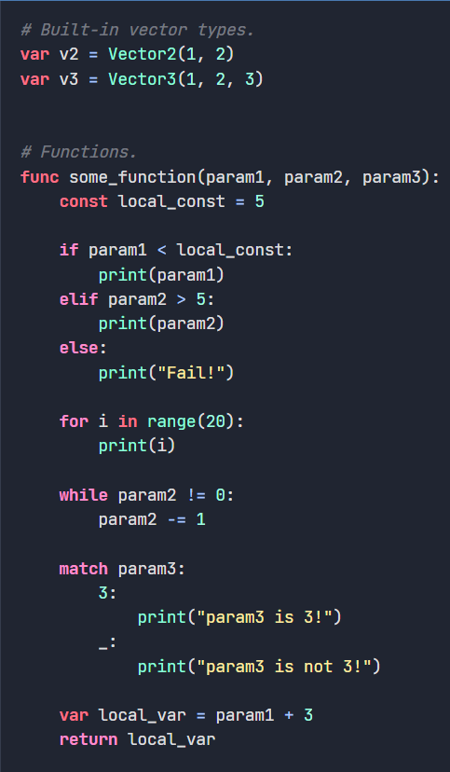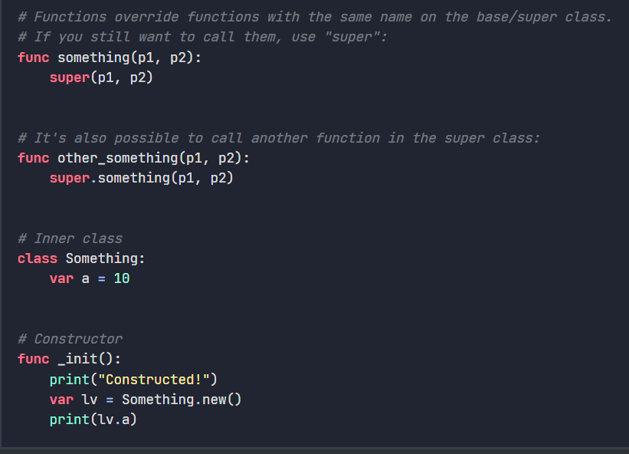

(13)

## 3.4. Godot Audio system

Godot’s audio system allows users to be immersed into their virtual worlds. Audio isn’t only used for VR related games but also non-VR games like 3D games or 2D games. It offers a wide range of features making it flexible and a versatile tool for game developers. The Audio can be used to make a sound when a certain object bounces off a surface or make music play in the background. Volumes can be set by using the volume DB and can either be typed in or used via a slider. The Autoplay automatically plays as soon as the user is inside the level that uses that sound/music.

(14)

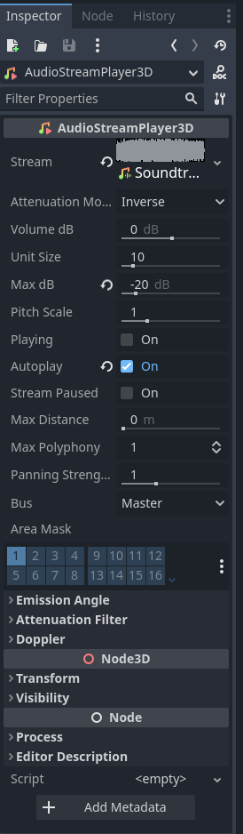

## 3.5 Conclusions

Having a good design methodology provides you with a well organized and structured set of techniques that make designs easier to develop and it also reduces the amount of time that is spent on accomplishing the project since you split up the harder and easier task and tackle on the harder tasks. This project is developed using the agile methodology since it will require more then one test to make sure that the final product brings the customer satisfaction.

# 4. Testing and Evaluation

## 4.1. Introduction

This chapter focuses on the ways in which the project will have to undertake certain number of tests to better understand what needs to be added or taken away, the VR game centring around Bilateral integration will be used by children that are in schools and have a mental disability that hindered their learning about correctly on how to coordinate their body with their brain.

### 4.2.1 Plan for Testing

The project will have to undertake physical testing, meaning that the headset and the game within the game engine will have to be present in order to be used. The project has been stored on GitHub so anyone can easily access it. The user will then have to download the Godot game engine, followed by setting up the headset and making sure that all the configurations are set. The headset will have to calibrate the height of the user and also it will have to measure out and scan the room using the cameras at the front of the headset, another way to measure out the room is using the controllers to manually draw the boundaries around the room. This boundary acts as a guardian that shows the user if they step towards a wall or any other object that can render hazardous to the user. My supervisor Bryan Duggan will get me in contact with a therapist that will allow me a chance to ask questions regarding bilateral integration which will give me a greater understanding of bilateral integration. The test will revolve around the kids using the bilateral integration game one by one since everyone is different in their own ways. So having more then one user will allow me to understand if there are any common problems or any common areas of the game that the kids found interesting or entertaining to use.

### 4.2.2 Steps in installing Godot game engine.

You have to first go onto their official website. The link is provided under the image as well as a refence that is located in the bibliography and the image too.

<https://godotengine.org/>

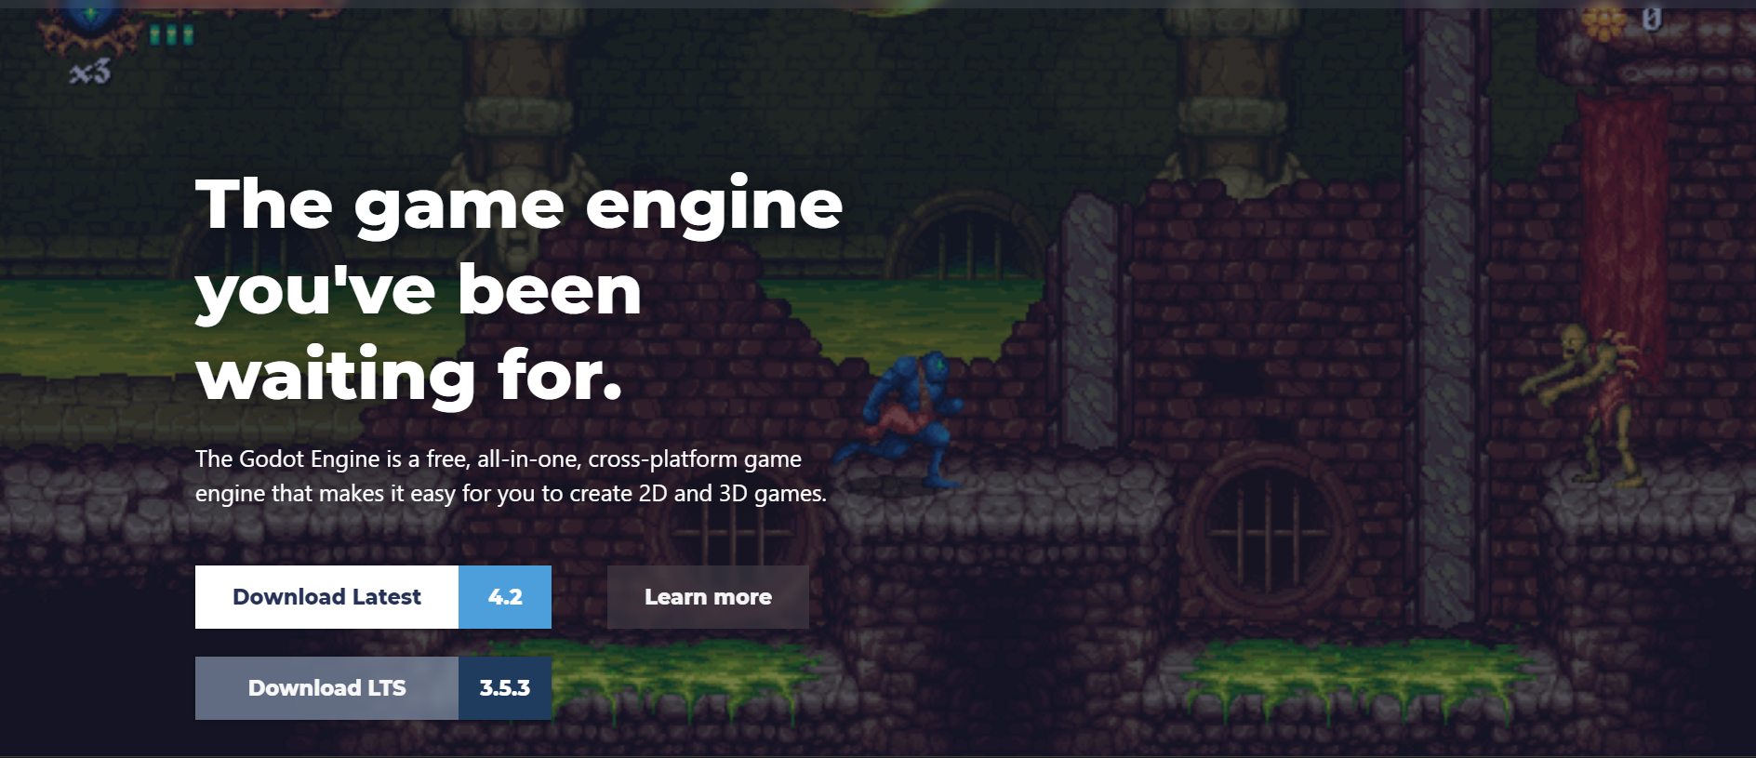

(15)

Follow the installation instructions and once you have installed Godot, proceed to the folder path that you gave during the installation process. Once you have found the folder proceed to open up the .exe application

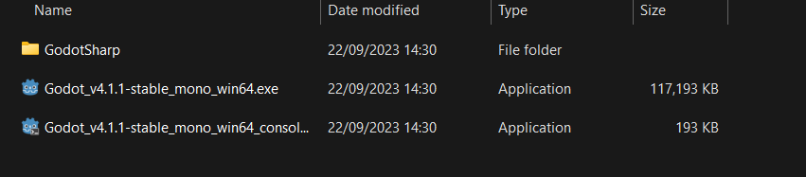

Once the application opens up, you will see something similar in accordance to the image below. navigate to the right side of the application and you should see the import button

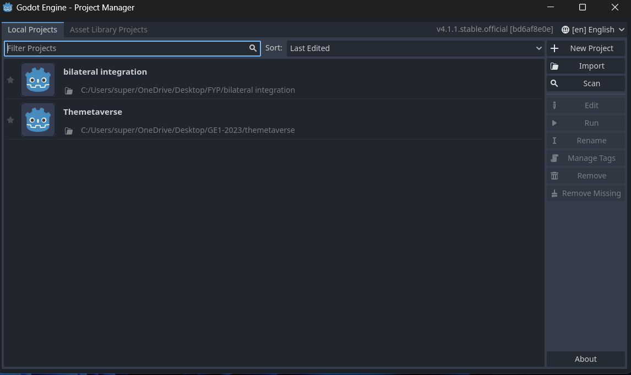

Once that is pressed you will see the following popup box that asks you to import the project.godot. how to get the project.godot will be explained in the next section

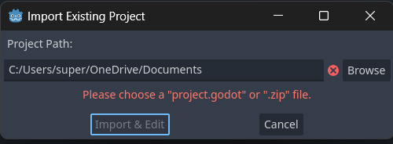

### 4.2.3 Getting the project folders and importing project.godot

To get the project.godot file you will have to download the folders that contain the project game. You will have to access the github and find the project. The link below takes you to the projects github

<https://github.com/C20321456/FYP>

(16)

You then click on “<> Code” then you click the copy button or you can manually copy the link that is provided.

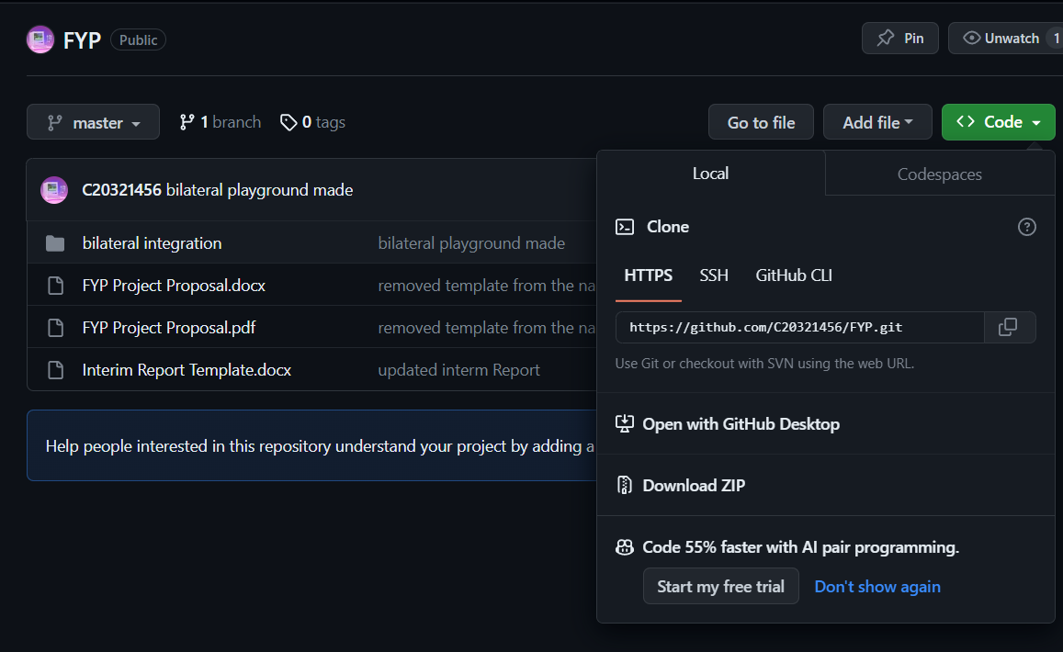

Then on your desktop, press shift and right click (depending on the version of windows. This works on windows 11. A simple right click might also give the option to run command prompt) and click on “open in terminal”

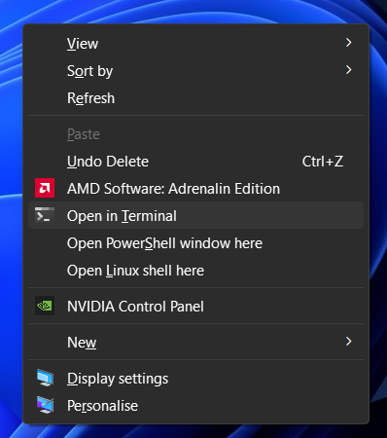

On the terminal or command prompt type in “git clone <link to the gitrepo>” you can paste the link as shown in the image below. Once you click enter it should start cloning the projects GitHub repository.

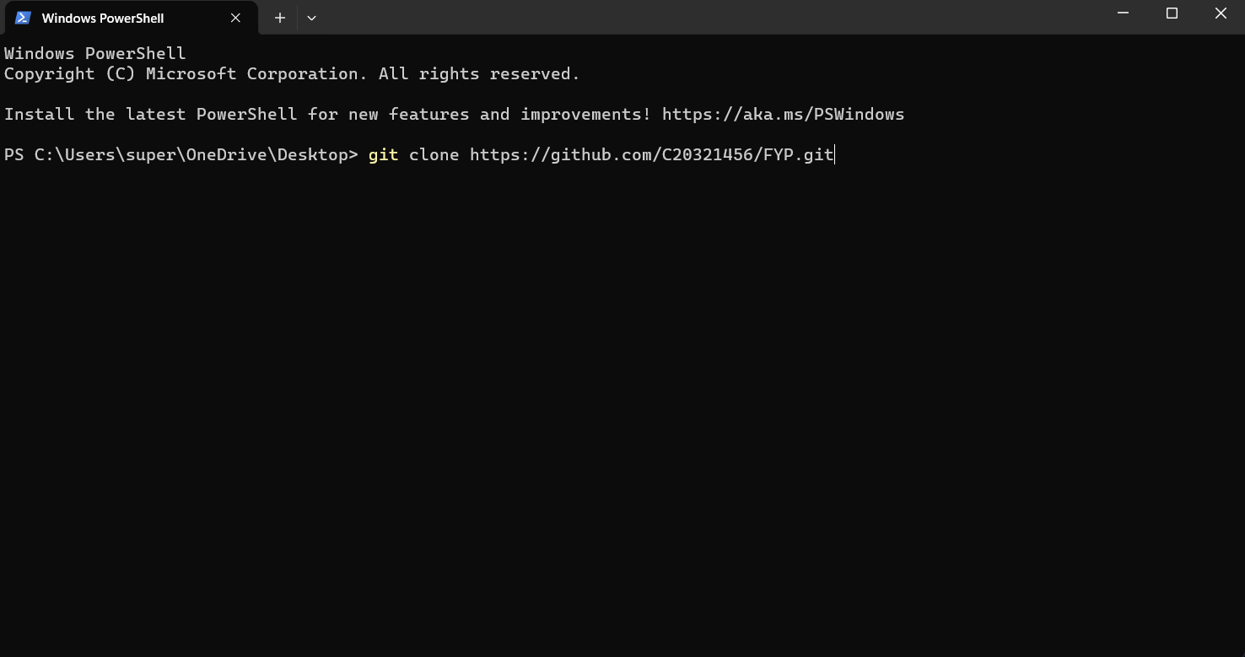

### 4.2.4 Opening the game onto Godot.

In the previous step, I talked about the pathing to project.godot. this is usually found within the folder. So once you click import on Godot you should click on browse and navigate to the project.godot file. Once its selected click on import and edit

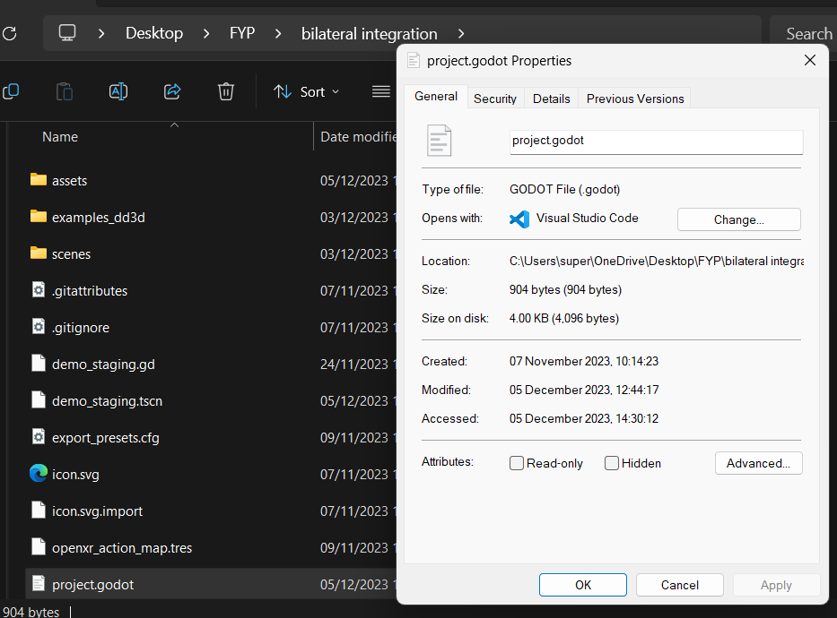

When Godot opens, navigate to the bottom left of the game engine. double click on demo_staging.tscn and that should load up the main scene on Godot. When it does click on “Run current scene”. The icon should look like this. 

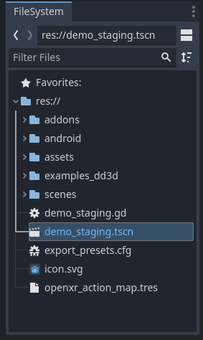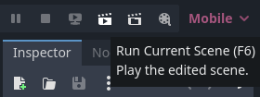

Note: make sure that the headset is first plugged into the laptop/PC before running the game as the game needs to detect the headset so it can function as intended.

### 4.3.1 Plan for Evaluation

The plan of evaluation will revolve around the project being tested out first and given proper expert evaluation. Then the therapist or the teacher in charge of teaching the kids will provide me with necessary feedback since anything that they say will have to be assessed and if any problems occur will have to be fixed, since an uncomfortable virtual world isn’t a fun world. With the feedback that I will get, I will work on fixing out the game in order to satisfy my target audience.

## 4.4. Conclusions

The testing will be a functional test as to be in line with the agile methodology to go in line with the deploy, test and review steps. The projects aim is to make the Virtual world an enjoyable experience for the user so that they would keep using the bilateral integration playground, if the user enjoys using the bilateral integration playground, then it encourages them to use it more often therefore helping the user get a better and faster grasp on the movements and get both sides of their brain working simultaneously.

# 5. Prototype Development

## 5.1. Introduction

In this chapter, it will cover the prototype development that will be readily deployed for its first testing phase, it is important to test the game so that users don’t encounter any motion sickness or any discomfort during their playtest.

## 5.2. Prototype Development

The protype has a few levels that aim to be used for the testing as it aligned with the bilateral integration exercises used by real world teachers and therapists that help with the integration for younger kids with mental disabilities. This section will cover what each level does and how it helps with bilateral integration.

### 5.2.1 Loading screening/start scene.

In the game there is a staging scene that will be the first scene that the user will see when putting on the headset and starting off the game. This scene is placed so that the user can ready themselves and make sure that the headset is adjusted properly and that the controllers have enough battery life in them as well as making sure that the headset is sufficiently charged up, once the user is ready to go they will see an instruction on the screen indicating the user to hold the trigger button on the controller which is usually found at the front of the controller and is usually pressed with the index finger. Once the trigger is pressed a circle will appear next to the text indicating that the user has to keep pressing the trigger for a certain amount of time before the scene switches to the next scene which will be the main room that the user will be set in.

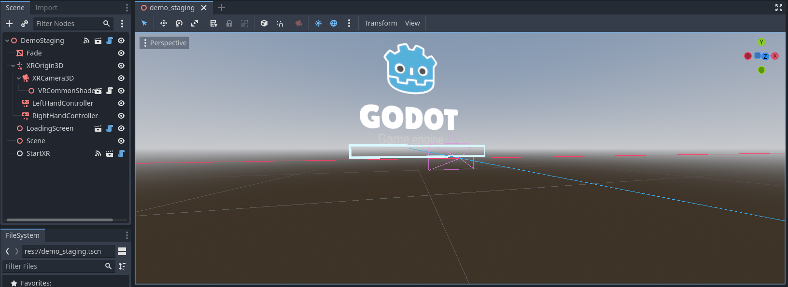

### 5.2.3 Main menu room

The main menu room is a scene in which the user will be placed after the loading screen finishes up and places the user in the main room. Within the main room holds 13 different levels that the user can step inside. All the user has to do is step onto one of the teleporting pads and it will switch the scene to the scene that the user has chosen. A few rooms are helpful for bilateral integration, some rooms are tutorial rooms like walking or climbing. The screen that the user will see in front of them is a settings UI screen, on the screen are settings for adjusting the dead zone for the controllers. Dead zones are essentially the distance that the user will have to move their thumbsticks before the game itself recognizes that the user is moving, meaning that a low dead zone makes the user to move when even slightest movement of the thumbsticks is detected, a higher dead zone means that you will have to move the thumbsticks more in order for the player to make any movement. The settings were set to make it as comfortable as possible for movement, but the user can change it if they wish.

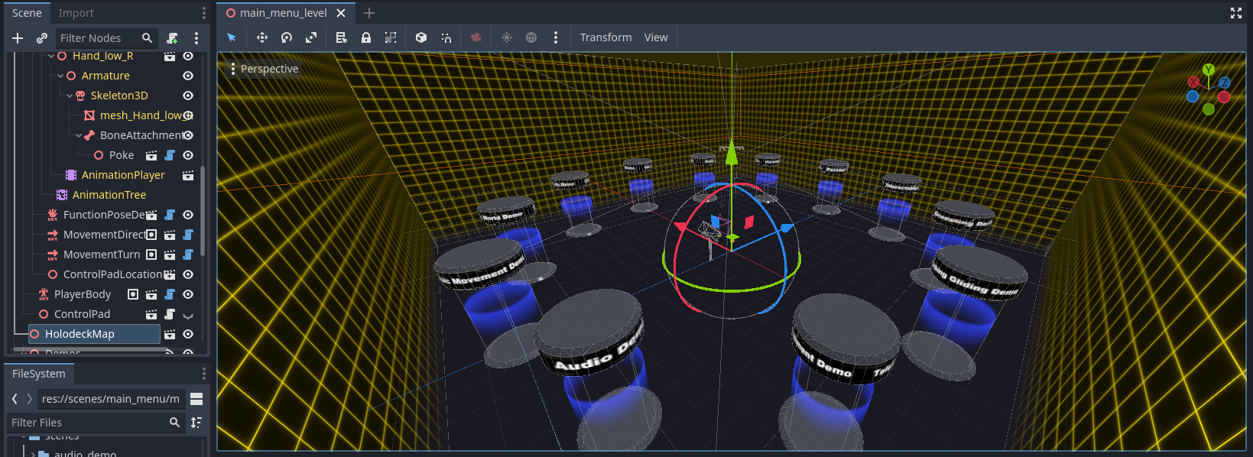

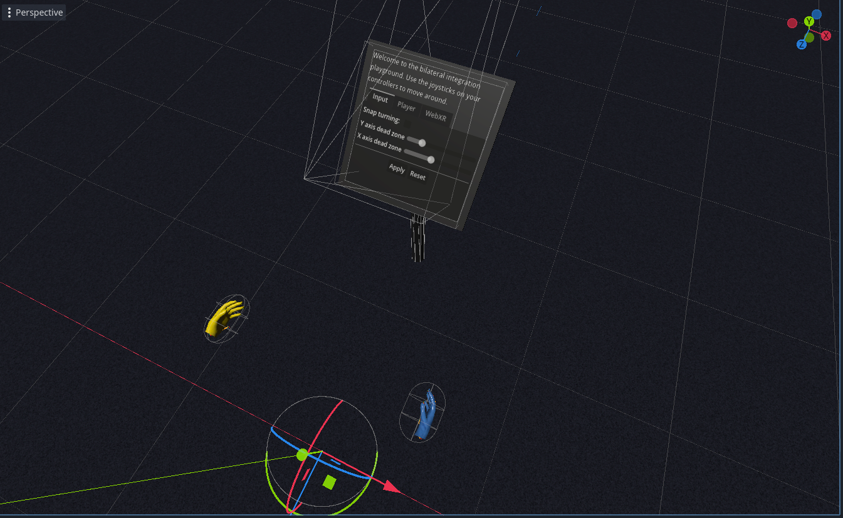

(17)

### 5.2.4 Pickable demo scene

One of the scenes that the user can enter into is the pickable demo scene. This scene was a variety of objects that the user can pick up. These are knives, teacups, balls, hammers, cubes, and other shapes. The user will notice a circle on their index fingers. These are pointers that if faces in front of a pickable object i.e. the ball. Then if the user holds the thumb grip (found on the side of the controllers) the ball is snap quickly towards their hand and they will be holding the ball in their hand. They can do whatever they want to with the ball like throw it around. The hammer also works the same way but unlike the balls you have to grab it by the handle, and it will automatically snap towards your hand. The top of the hammer has collision meaning that you can hit the ball around and have a small game of golf. The teacups also are pickable, but it has a specific way of holding the cup, meaning you can’t hold it anyway you want. When you try to pick up the cup it will snap to your hand and you will hold it by the handle, and when you let go instead of it dropping onto the ground, it will snap back onto the holder. Should the user wish to go back, they can step back onto the teleportation pad and be sent back to the main room. This scene is useful for bilateral integration since real world examples utilise the ability of grabbing and holding objects.

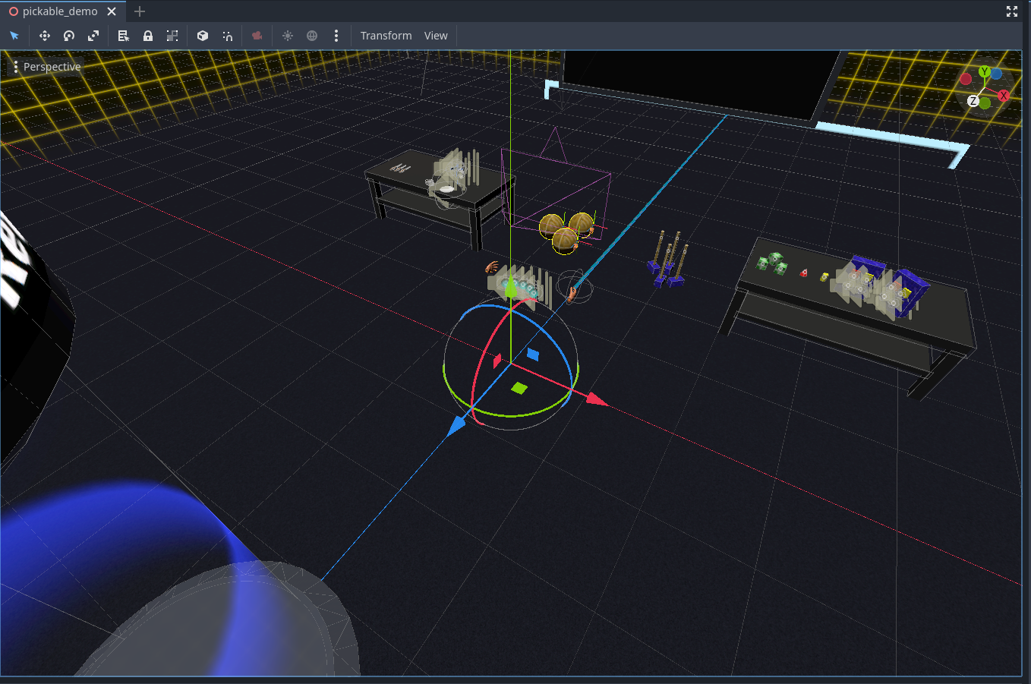

### 5.2.5 Poke/whiteboard scene

This scene contains a poke function, this means that in this scene the user will mainly use their index finger. The first thing that the user will see will be a screen that is blank, this is a whiteboard in a way that only contains a single colour which is black, they can use their index finger to draw anything they want onto the board. You can use both hands to draw or a single hand since the poke function is applied to both of the index fingers. The user will also notice three cubes placed on top of a table; these cubes remain still until the user uses their index finger to push the cube around. Thus they will be poking them, there isn’t a lot of things present within the scene but its import to bilateral integration exercises, one of them is to be able to draw the infinity symbol, they will have to trace it again and again until they get a better matching trace of the infinity symbol.

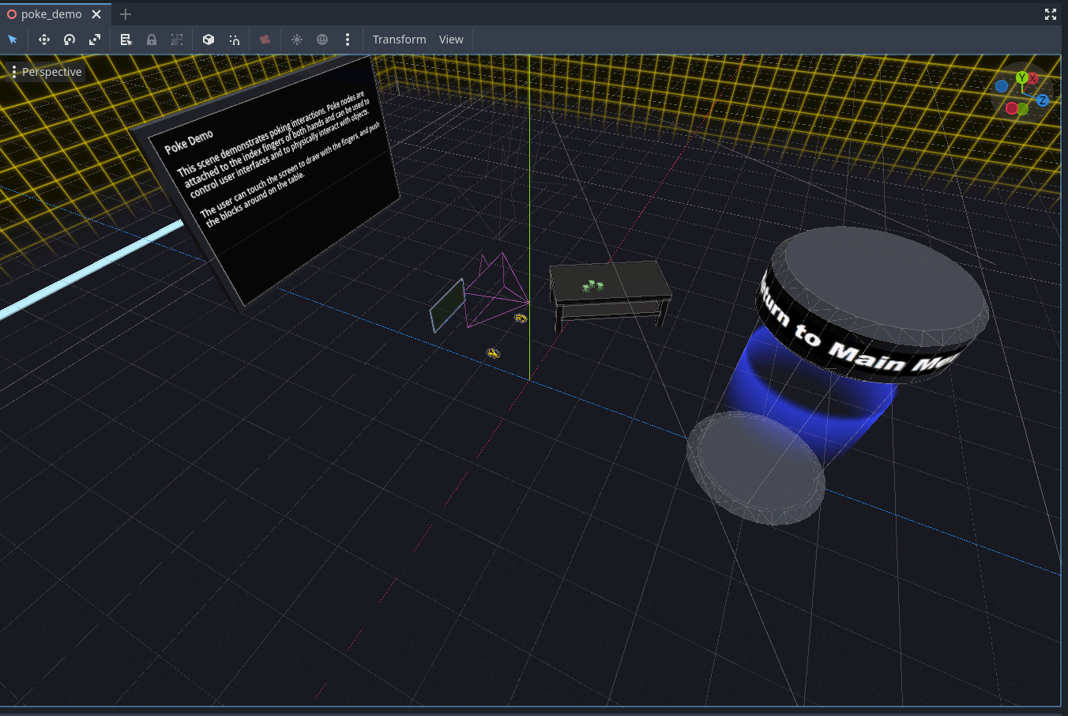

### 5.2.6 Sprinting demo

This is a tutorial scene that shows the user how to use the ability to run. When the user loads into the scene they will be met by the board that gives them instructions on how to run, they have to press down on the left thumbstick to be able to run, a running track has been provided for the fun of the user to run around in circles, on the sides of the scene are different walls that hold pads. These pads are grabbable meaning that the user could climb up the wall if they wished, the climbing bit is good for bilateral integrations as it utilizes both hands since one hand grabs onto a pad and the other hand is stretched out to grab another pad. The hands have to work in unison in order to establish a successful climbing experience.

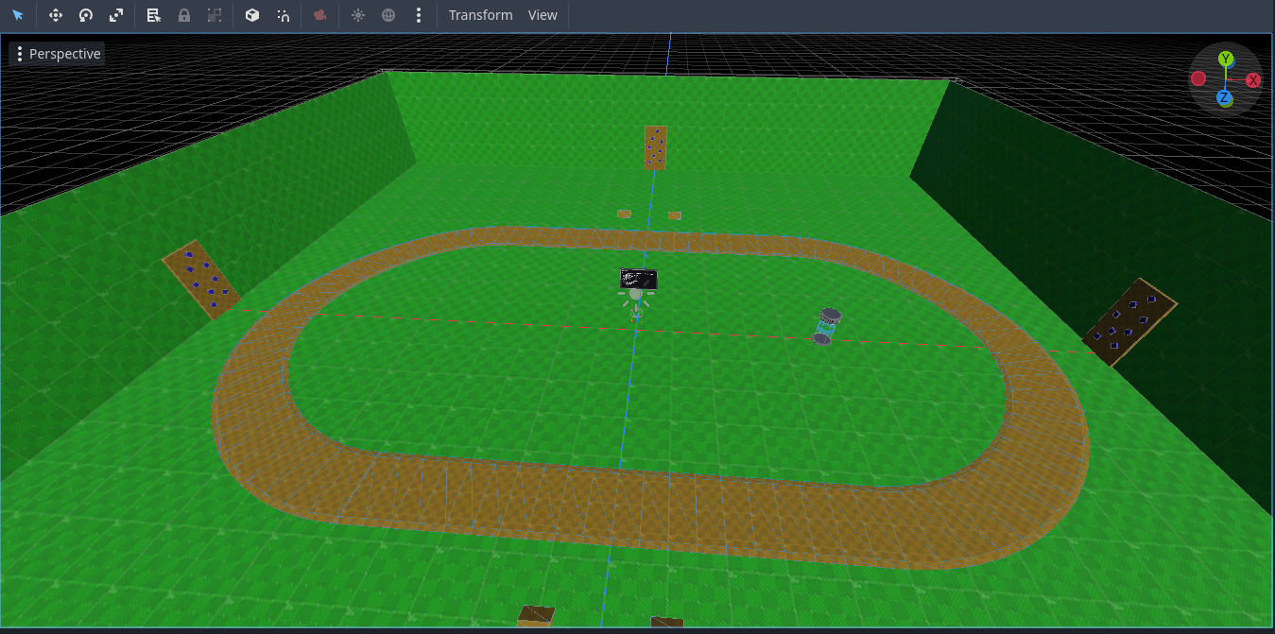

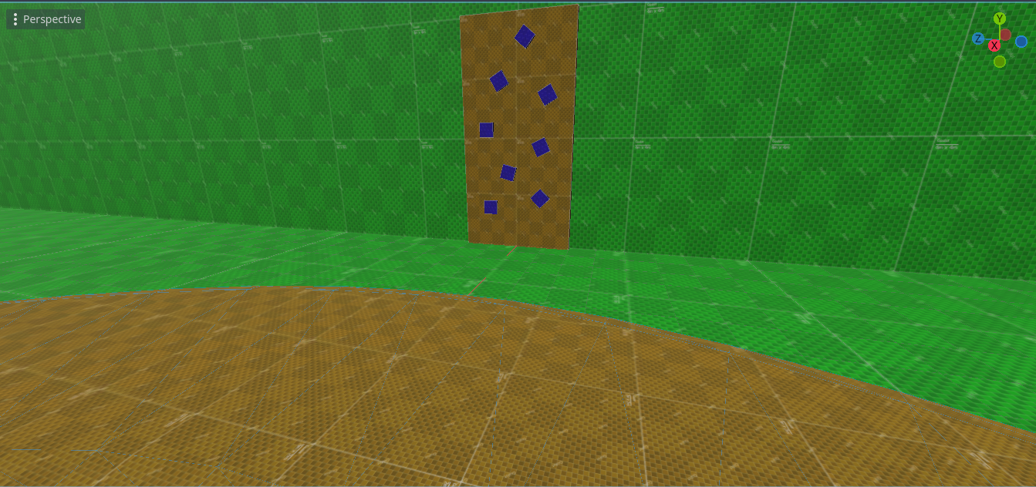

### 5.2.7 Gliding scene

In this scene the user can have the enjoyment of gliding like a bird in the air, when the user enters into the scene they will be standing on a platform. The user will see a screen with instructions detailing how they can glide and even fly. The user needs to stretch both their arms apart putting themselves in a T pose, similar to how actually bird’s fly. To fly upwards the user will have to flap their arms as if they were wings. The arms need to be moved at the same time; this is useful for bilateral integration as the hands have to be moved in unison.

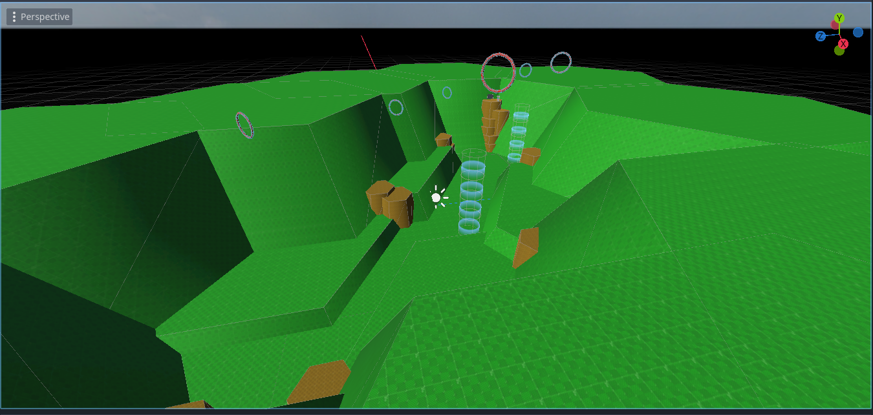

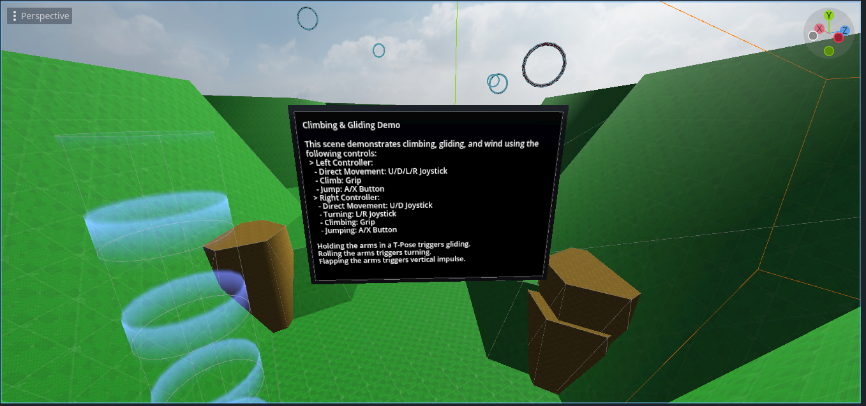

## 5.4. Conclusions

In order for the project to have VR enabled, Godot utilizes the node called XRCamera3D, this allows the user to slip on the headset and see the virtual world around them, the XR-toolkit helps with enabling the camera functionality, the kit allows gives rendered hands that look like gloves on the user which is useful for interacting with the virtual world around them.

# 6. Issues and Future Work

## 6.1. Introduction

This chapter focuses on issues and plans on the project might go on in the future. Virtual reality games come with problems that might affect the user experience of a person. These risks aren’t really deadly, but it can cause mild discomfort to the user, VR usage should remain short as to not encounter any discomforts to the user.

## 6.2. Issues and Risks

There are a few risks when it comes to using the VR headset. These can include health problems, addiction, social issues and also privacy concerns. It can also cause physical problems to the user if they aren’t careful around their playing field. Although these issues aren’t hazardous that should discourage users from enjoying VR, but when using VR, they should understand the cautions of what might happen if they aren’t careful and they should keep themselves clear from these problems, then the user will have an enjoyable time in the VR world.

### 6.2.1 Social issues

Virtual reality can be anything that the creator wants to make it, they can make their own virtual lives that can have jobs, make new friends, and enjoy experiences such as fantasy adventures using virtual and augmented reality. If such a world like that exists, then why should a person leave a fun world where they can do anything that they can’t do in real life? Its easy to get lost in the pleasures of the virtual world and lose sight of what really matters. This can affect your social status with others since you wouldn’t really care about hanging out with friends outside. Because you can do it all in the virtual world. However, tempting it may be the imaginary world cant replace the real world that we are currently living in.

### 6.2.2 Addiction and distorted sense of reality

Its easy to get addicted to something that promises an escape from the real world. Virtual reality is mostly used for entertaining purposes and long-terms of expose to the virtual world can lead to addiction. There are noticeable symptoms that can help identify if a person is addicted to the virtual world, for example they can feel frustrated when they are unable to use VR. Not doing chores or other real-world needs and tasks, not wanting to spend time with their friends and family. According to a study by the Communication University of China, VR Gaming is 44% more addictive than PC gaming (18). It is important that there is a balance kept between VR and real life so you won’t develop an addiction.

### 6.2.3 Health problems

VR may pose some health risks and concerns, for example accidently hurting yourself by your surroundings when you accidentally run into a wall or if you are playing a fighting game you may punch the wall which can cause both damage to your hand and the controllers which is why it may be advised to have someone watching over you to make sure you don’t run into anything . The user may also experience motion sickness and it can also cause eye issues like eye strains, our brain doesn’t understand the difference between the real world and the virtual world. Common reason why users feel motion sickness is the fact that while they are standing still in a room, their in-game character is always moving and turning this confuses the brain since it doesn’t actually know if you are really moving, you’re standing still but also moving. It is important to take breaks in between game sessions as to avoid any sickness or eye strains. Maintaining a healthy break cycle gives the user an opportunity to have a more enjoyable time in VR.

### 6.2.4 Privacy concerns

VR may collect data from its users more than any other conventional technology. VR headsets have a microphone installed into them to allow the users to communicate with other people in the virtual world, that means that the microphone can be listening to the conversations that are being talked, eye tracking can record what the user is looking at and it also gathers biometric information which can be similar to getting someone’s identity. To minimize unauthorized access, it is advised that data should be cleared.

(19)

(20)

(21)

### 6.2.5 Benefits of using VR

While there are health risks associated with VR it isn’t all that bad. VR can have benefits too, for example VR can be used in education and training purposes. It creates an immersive, interactive environment that helps to improve learning, simulate real-world scenarios, and also enhance empathy, ultimately advancing fields like education, healthcare, and entertainment. The most important benefits of virtual reality are immersive learning, realistic simulations for skill development, and increased engagement, making it a valuable tool for education, training, and experiential learning in various fields.

(22)

(23)

## 6.3. Plans and Future Work

For the future work the project will under many tests since each test will provide me back with useful feedback, and with the feedback I plan to improve and add additional features, like adding more levels that correspond to bilateral integration. I plan on seeing my project and its many prototypes being used by the children with mental disabilities as it will grant be a better insight of how they use and to see if they are able to perform the tasks within the virtual environment safely while also enjoying the many different levels within the game. Another feature what I would like to add but don’t really have much insight if its even possible but if it is then I would like to add game recordings into the game, this will allow for the screen to be recorded so that the teacher can do a review to see how each child preformed, it allow the teacher to see how long each child took within each section of the levels. This will be great for feedback as that will give me an insight if a level is way too difficult for the children to play. That will allow me to make modifications to parts of the level and change it up or even remove the level if it doesn’t help with bilateral integration.

### 6.3.1. GANTT Chart

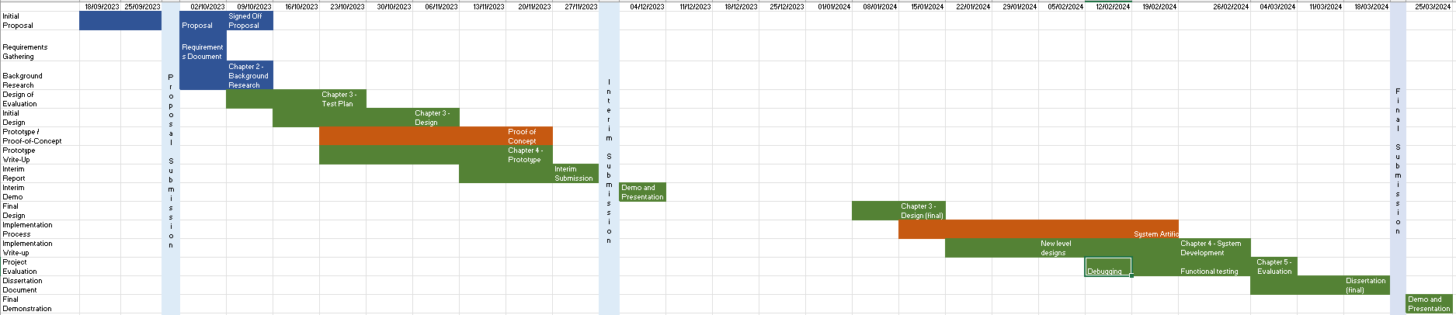

# Bibliography

1. Beck C. Bilateral Integration [Internet]. The OT Toolbox. 2022 [cited 2023 Nov 21]. Available from: https://www.theottoolbox.com/bilateral-integration/

2. EEG Headset [Internet]. EMOTIV. [cited 2023 Dec 7]. Available from: https://www.emotiv.com/glossary/eeg-headset/

3. Buy EEG Headset online ’ Now available at MindTecStore [Internet]. [cited 2023 Dec 7]. Buy EEG Headset online ’ Now available at MindTecStore. Available from: https://www.mindtecstore.com/neurofeedback/eeg-headsets_en

4. About Amelia Virtual Care | VR Software for Mental Health [Internet]. Amelia Virtual Care. [cited 2023 Nov 21]. Available from: https://ameliavirtualcare.com/about-us/

5. Meta Quest 3: New mixed reality VR headset – Shop now [Internet]. [cited 2023 Dec 5]. Available from: https://www.meta.com/ie/quest/quest-3/

6. Statista Daily Data [Internet]. 2023 [cited 2023 Dec 5]. Infographic: Meta Leads the Way in VR Headsets. Available from: https://www.statista.com/chart/29398/vr-headset-kpis

7. Godot Engine documentation [Internet]. [cited 2023 Nov 21]. Introduction to Godot. Available from: https://docs.godotengine.org/en/stable/getting_started/introduction/getting_started/introduction/introduction_to_godot.html

8. L’Italien R. What Is Unreal Engine 5 | Perforce [Internet]. [cited 2023 Dec 5]. Available from: https://www.perforce.com/blog/vcs/unreal-engine-5

9. Godot Engine documentation [Internet]. [cited 2023 Dec 5]. Introducing XR tools. Available from: https://docs.godotengine.org/en/stable/tutorials/xr/tutorials/xr/introducing_xr_tools.html

10. What Is a Software Development Methodology? (With 11 Types) | Indeed.com Australia [Internet]. [cited 2023 Dec 5]. Available from: https://au.indeed.com/career-advice/career-development/software-development-methodology

11. Agile Methodology I Official Trainings - InterQuality [Internet]. [cited 2023 Dec 5]. Available from: https://interqualitybg.com/en/resources/scrum-and-agile-resources/agile-methodology

12. Waterfall Methodology – Ultimate Guide [Internet]. 2022 [cited 2023 Dec 5]. Available from: https://management.org/waterfall-methodology

13. Godot Engine documentation [Internet]. [cited 2023 Dec 5]. GDScript reference. Available from: https://docs.godotengine.org/en/stable/tutorials/scripting/gdscript/tutorials/scripting/gdscript/gdscript_basics.html

14. Godot Engine documentation [Internet]. [cited 2023 Dec 5]. AudioStreamPlayer. Available from: https://docs.godotengine.org/en/stable/classes/classes/class_audiostreamplayer.html

15. Engine G. Godot Engine. [cited 2023 Dec 5]. Godot Engine - Free and open source 2D and 3D game engine. Available from: https://godotengine.org/

16. Cooper M. C20321456/FYP [Internet]. 2023 [cited 2023 Dec 5]. Available from: https://github.com/C20321456/FYP

17. Old V is TN. What is a dead zone in controller? [Internet]. 2023 [cited 2023 Dec 6]. Available from: https://www.vintageisthenewold.com/game-pedia/what-is-a-dead-zone-in-controller

18. Skarredghost. VR is 44% more addictive than flat gaming (according to a study) [Internet]. The Ghost Howls. 2022 [cited 2023 Dec 6]. Available from: https://skarredghost.com/2022/03/02/vr-virtual-reality-metaverse-addictive/

19. Educative [Internet]. [cited 2023 Dec 6]. What are the potential risks of virtual reality? Available from: https://www.educative.io/answers/what-are-the-potential-risks-of-virtual-reality

20. Anses - Agence nationale de sécurité sanitaire de l’alimentation, de l’environnement et du travail [Internet]. 2021 [cited 2023 Dec 6]. What are the risks of virtual reality and augmented reality, and what good practices does ANSES recommend? Available from: https://www.anses.fr/en/content/what-are-risks-virtual-reality-and-augmented-reality-and-what-good-practices-does-anses

21. LaMotte S. CNN. 2017 [cited 2023 Dec 6]. The very real health dangers of virtual reality. Available from: https://www.cnn.com/2017/12/13/health/virtual-reality-vr-dangers-safety/index.html

22. Why Virtual Reality Is Important: Exploring the Benefits of VR [Internet]. [cited 2023 Dec 6]. Available from: https://www.talespin.com/reading/why-virtual-reality-is-important-exploring-the-benefits-of-vr

23. 7 Benefits of Virtual Reality | Futuclass [Internet]. [cited 2023 Dec 6]. Available from: https://futuclass.com/blog/benefits-of-virtual-reality/